**Week9-10 MST Lec 24-25**

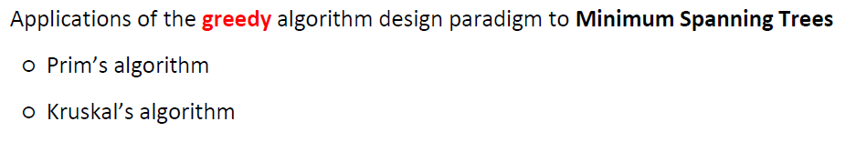

* A spanning tree is a tree that connects all of the vertices in the graph.
* The cost of spanning tree is the total sum of the weight of its edges, an MST of a graph is a spanning tree of the graph with minimum cost.

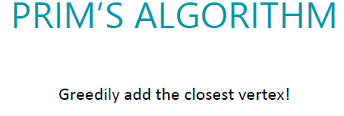

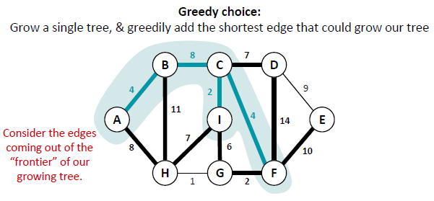

* Basically Prims algo aik greedy algo hai iss mei ham aik vertex select krty hein or usky bad uss se connected sb sy minimum costing edge select kr lety hein we keep doing it till all graph is traversed as it can be seen from the above picture.
* The pseudocode of prims algo is give below

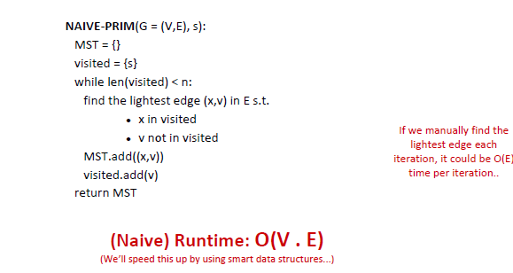

* The naïve runtime of Prim’s algo is O(V.E)
* Run time of Improvised Prim’s algo is O(E log V)

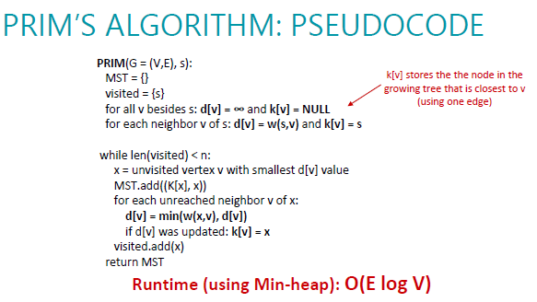

Kruskal Algorithm

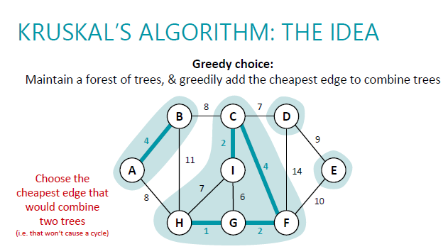

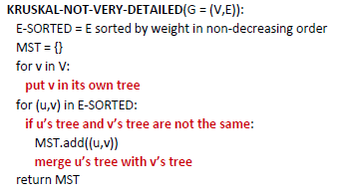

* Kruskal algo detailed code

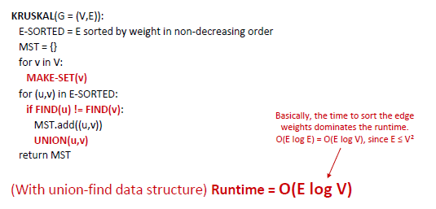

**Week12 Single source shortest paths, all pairs shortest paths_verU Lec 28-30**

**Bellman Ford Algo**

* Dp algo
* Works when some weights are -ve
* Doesn’t work when -ve cycle exists in graph
* If there is no -ve cycle it returns the shortest path in |v|-1 iterations

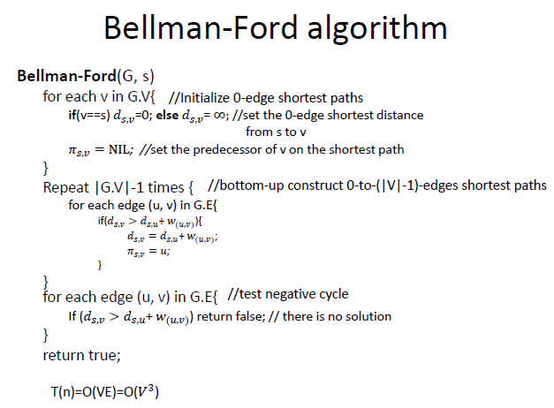

* **Dijikstra Algo**
* It’s a greedy algo with time complexity of O(V^2)

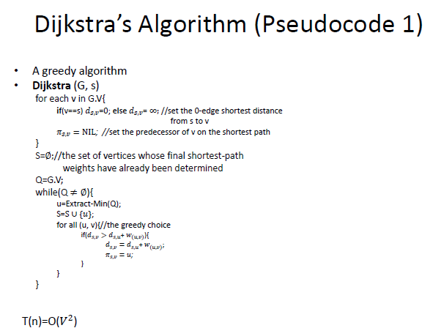

* **Floyd Warshall Algo**
* Works on -ve weights but no -ve cycle should be present.

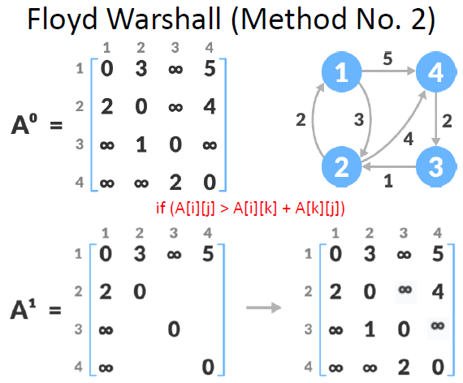

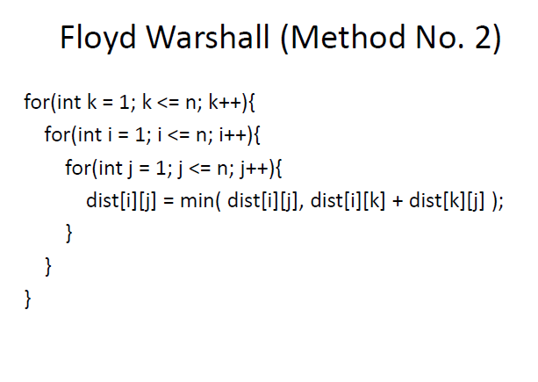

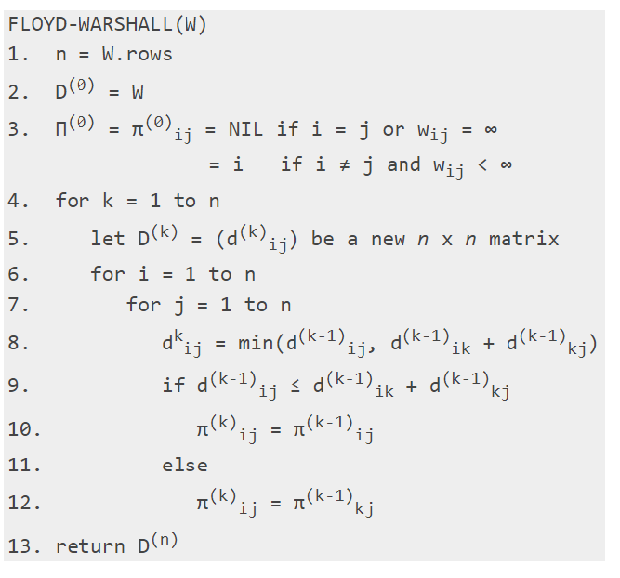

**Week13-14 NP-Completeness, P, NP, NPC, NP-Hard, Approximation algo, reduction - Final Lec 31-36**

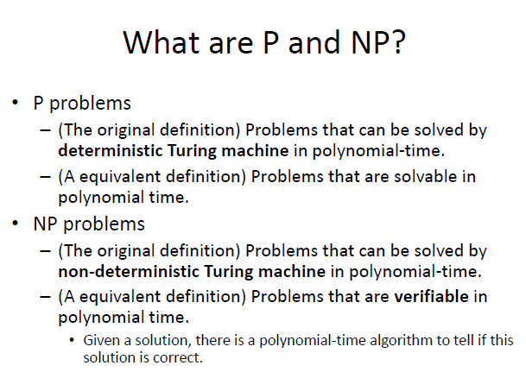

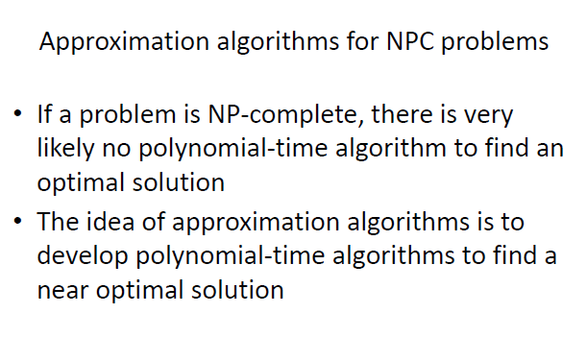

* Vertex cover problem

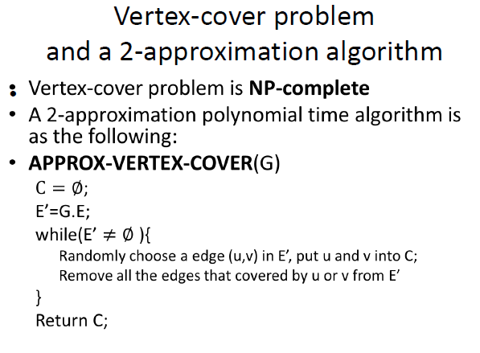

* Travelling salesman problem
* 